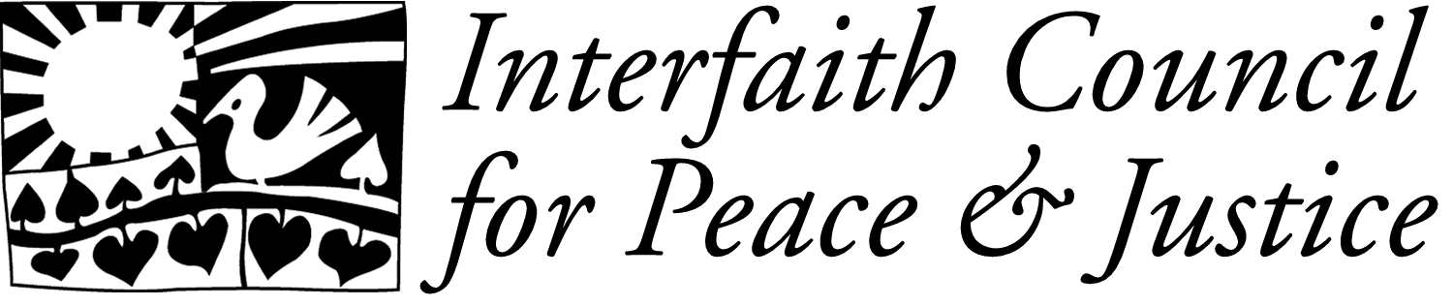
Presents…
Scriptural Reasoning IV
sponsored by ICPJ’s Common Ground Working Group

Reconciliation in the Sacred Texts

Tonight’s speakers will briefly share their perspectives on how their Scriptural Texts relate to the topic. Small group discussion will follow. *Note cards are available at your table for you to record questions that you may have for the speakers. The speakers will address several of these questions following the small group discussions. Our event tonight will conclude ~8:30pm.

Speakers

Pastor James Rhodenhiser
St. Clare’s Episcopal Church, Ann Arbor

Dr. Soraya Orady
Founder and president of the Islamic Education and Resources Network (ILearn)

Rabbi Elliot Ginsburg
Pardes Hannah minyan in Ann Arbor and Associate Professor of Jewish Thought and Mysticism at the University of Michigan

~ Discussion Questions in Small Groups ~

- What kind of examples does your religious text offer of reconciliation? Are their different visions of how reconciliation happens in your scriptures? Does it offer specific guidance for how to approach reconciliation? If so, how?

- Are there any certain or extreme conflicts/situations that your scriptures suggest are so harmful that no reconciliation is ultimately possible?

- How does your religious tradition approach the issue of reconciliation with those whose actual behaviors have been hurtful and have created mistrust?

- Has your scripture on reconciliation been interpreted in different ways, depending on different situations?

Please visit the ICPJ website (www.icpj.net) for more information on Common Ground’s Scriptural Reasoning Series. Thank you for joining us!

